**CHAPTER ONE**

**INTRODUCTION**

**1.1 Overview**

In today's fast-paced digital era, technological advancements have revolutionized various aspects of our lives, including the way educational institutions operate. One crucial aspect of managing educational institutions is attendance tracking. Traditionally, attendance tracking has been a time-consuming and manual process, prone to errors and inefficiencies. However, with the advent of online systems and automation, educational institutions can streamline and enhance their attendance management processes. This chapter introduces the development of an Online Automated Attendance System, with a focus on a case study conducted at Baze University in Abuja.

**1.2 Background and Motivation**

Attendance tracking has been a fundamental aspect of educational institutions for many years, and its methods have evolved over time. The traditional approach to attendance management involved manual processes, such as taking roll call in classrooms and manually recording attendance data on paper registers (Liu, Yang, & Liu, 2019). These paper-based systems were time-consuming, prone to errors, and made it challenging to retrieve and analyze attendance data efficiently.

With the advent of technology and the widespread use of computers and the internet, educational institutions started exploring digital solutions for attendance tracking. The early digital systems involved the use of spreadsheets or rudimentary software applications that automated the process of recording attendance (Kumar, & Srivastava, 2017). However, these systems still relied on manual data entry and lacked real-time monitoring capabilities.

The motivation for developing an Online Automated Attendance System arises from the limitations and inefficiencies of manual and early digital attendance tracking methods. The need for a more efficient, accurate, and real-time attendance management system has become increasingly evident. Educational institutions, including Baze University in Abuja, recognize the potential benefits of implementing an automated system to streamline attendance tracking processes and improve overall efficiency (Liu, Yang, & Liu, 2019).

An Online Automated Attendance System offers several advantages over traditional methods, such as reduced administrative workload, improved accuracy, real-time monitoring, and the ability to generate comprehensive attendance reports and analytics (Kumar, & Srivastava, 2017). By leveraging technology, educational institutions like Baze University aim to enhance their attendance management practices, optimize resource allocation, and create a more conducive learning environment for students.

In summary, the background of attendance management systems dates back to manual paper-based methods, which have gradually evolved into digital systems. The motivation for developing an Online Automated Attendance System stems from the limitations of traditional and early digital systems, as well as the potential benefits of automation and real-time monitoring in improving attendance management processes.

**1.3 Statement of the Problem**

The existing manual attendance tracking system at Baze University is labor-intensive, time-consuming, and error-prone. The process involves manual collection of attendance data, which is then inputted into spreadsheets or other record-keeping tools. This manual approach poses several challenges, including the potential for data entry errors, difficulties in data retrieval and analysis, and delays in generating attendance reports. Furthermore, the lack of a real-time monitoring mechanism hampers the university's ability to promptly address attendance-related issues or identify trends and patterns.

To address these challenges, an Online Automated Attendance System is proposed as a solution. This system aims to automate the attendance tracking process, eliminate manual data entry, and provide real-time access to attendance records, thereby enabling efficient management and analysis of attendance data.

**1.4 Aim and Objectives**

The aim of this project is to develop an Online Automated Attendance System for Baze University, Abuja, with the following objectives:

1. To automate the process of capturing and recording student attendance.
2. To provide real-time access to attendance records for faculty, administrators, and students.
3. To generate comprehensive attendance reports and analytics for decision-making.
4. To enhance efficiency in attendance management and reduce administrative workload.
5. To improve accuracy and eliminate errors associated with manual attendance tracking methods.

**1.5 Significance of the Project**

The development of an Online Automated Attendance System holds significant importance for Baze University and other educational institutions. The system's implementation will result in numerous benefits, such as:

1. Improved Efficiency: The system eliminates the need for manual attendance tracking, saving time and effort for faculty and administrators. It streamlines the process, allowing for quicker and more accurate recording of attendance data.
2. Real-Time Monitoring: The system provides real-time access to attendance data, enabling instant monitoring of student attendance. This feature allows for timely intervention and support to students who may be facing attendance-related challenges.
3. Data Analysis and Reporting: The system generates comprehensive attendance reports and analytics, facilitating data-driven decision-making. This information can help identify attendance patterns, track student progress, and implement targeted interventions where necessary.
4. Enhanced Transparency and Accountability: The system promotes transparency by providing an auditable record of attendance. It reduces the potential for manipulation or falsification of attendance data, promoting accountability among students and faculty.

**1.6 Project Risks Assessment**

The development and implementation of an Online Automated Attendance System for Baze University, Abuja, involve certain risks and challenges. The following table outlines these risks and provides a brief description of each risk and its potential impact on the project:

Table 1.1 Project Risks Assessment

|  |  |  |
| --- | --- | --- |
| Risk | Description | Impact |
| Technical Challenges | Potential technical difficulties in system development and deployment, including compatibility issues, data security concerns, and scalability challenges. | Delayed project timeline, increased development costs, compromised data security. |
| User Adoption | Resistance or reluctance from faculty, administrators, and students towards adopting and adapting to the new system. | Incomplete or inconsistent data input, reduced system utilization, limited benefits realization. |
| Data Integrity | Risks associated with maintaining data integrity, preventing unauthorized access or manipulation of attendance records. | Compromised data accuracy, potential privacy breaches, loss of trust in the system. |

It is important to note that these risks can be mitigated through proactive risk management strategies, such as conducting thorough system testing, providing comprehensive user training and support, implementing robust security measures, and ensuring open communication channels with stakeholders throughout the project. By addressing these potential risks, the project team can minimize their impact and increase the likelihood of a successful implementation of the Online Automated Attendance System at Baze University, Abuja.

**1.7 Scope and Organization**

This project focuses on the development of an Online Automated Attendance System specifically tailored for Baze University, Abuja. The system will encompass the entire attendance management process, from capturing attendance to generating reports and analytics. The scope also includes the integration of necessary hardware and software components, as well as user training and support.

The remainder of this project report is organized as follows: Chapter Two provides an overview of the existing attendance management systems and related literature. Chapter Three describes the methodology and approach used in developing the Online Automated Attendance System. Chapter Four presents the system implementation and testing. Finally, Chapter Five concludes the report with a summary of the findings, limitations, and recommendations for future enhancements.

**CHAPTER TWO**

**LITERATURE REVIEW**

**2.1 Introduction**

This chapter presents a comprehensive review of the literature related to the development of an Online Automated Attendance System. The literature review aims to provide a contextual understanding of the historical evolution of attendance management systems and highlight the existing research and practices in this field. By examining previous studies and related work, this chapter establishes a foundation for the current project and identifies gaps that the proposed system intends to address.

**2.2 Historical Overview**

The history of attendance management systems can be traced back to manual methods of recording attendance, such as paper-based registers and roll call. These traditional approaches were labor-intensive, time-consuming, and prone to errors. However, with the emergence of technology, educational institutions began exploring digital solutions to streamline attendance tracking processes.

Early digital systems primarily relied on spreadsheets or basic software applications for attendance management. These systems automated the process of recording attendance, but still required manual data entry and lacked real-time monitoring capabilities. Over time, advancements in technology led to the development of more sophisticated attendance management systems.

In recent years, there has been a shift towards online and automated attendance systems. These systems leverage various technologies, including biometrics (such as fingerprint or facial recognition), radio frequency identification (RFID), and barcode scanning, to automate the capture and recording of attendance data. They offer real-time monitoring, centralized data storage, and advanced reporting and analytics capabilities, revolutionizing the way attendance is managed in educational institutions.

**2.3 Related Work**

The literature review also examines previous research and related work in the field of online automated attendance systems. Several studies have focused on the development and implementation of similar systems in different educational settings. These studies highlight the benefits, challenges, and best practices associated with online attendance management.

For example, Kumar and Srivastava (2017) proposed an online attendance management system using face recognition. Their system utilized image processing techniques to identify and authenticate students, eliminating the need for manual data entry. The study demonstrated the effectiveness of facial recognition technology in automating attendance tracking and reducing administrative workload.

Liu, Yang, and Liu (2019) presented an online attendance management system based on RFID technology. Their system utilized RFID tags embedded in student ID cards to automatically track and record attendance. The study showcased the advantages of RFID technology in terms of accuracy, efficiency, and real-time monitoring.

One notable study by Bin Anuar, Zainal, and Yussof (2018) proposed an online attendance management system using QR code scanning. Their system utilized mobile devices with QR code scanning capabilities to capture attendance data. The study demonstrated the ease of implementation and user-friendliness of QR code technology in automating attendance tracking.

Another research conducted by Chatterjee, Mitra, and Bhattacharya (2018) focused on the development of an online attendance management system using a mobile application. Their system allowed students to mark their attendance through the mobile app, which utilized GPS technology to ensure location authenticity. The study highlighted the convenience and accessibility of mobile applications in capturing attendance data.

In the context of higher education institutions, a study by Al-Fahad, Al-Shammari, and Al-Hajraf (2016) investigated the implementation of an online attendance management system in a university setting. The system incorporated biometric authentication using fingerprint recognition technology and provided real-time attendance monitoring. The study emphasized the importance of user acceptance and engagement in the successful adoption of online attendance systems.

Furthermore, research by Yasin, Ahmad, and Hamzah (2018) explored the use of cloud-based systems for online attendance management. Their study discussed the benefits of cloud computing in terms of scalability, accessibility, and data security. The cloud-based system allowed for centralized attendance data storage and real-time synchronization across multiple devices.

A study by Mahajan, Kaur, and Singh (2018) proposed an online attendance management system using iris recognition technology. Their system utilized iris scanning for accurate and secure attendance tracking.

In a research conducted by Gupta and Gupta (2017), a facial recognition-based attendance system was developed. The system employed machine learning algorithms to recognize and verify students' faces for attendance purposes.

Jain and Keskar (2016) presented an online attendance management system using WSNs. The system utilized wireless sensors placed in classrooms to detect the presence of students and automatically record their attendance.

In a similar vein, a study by Srinivasan and Prakash (2018) proposed an IoT-based attendance management system using WSNs. The system employed RFID and WSN technologies to track and record attendance data.

A research by Hassan, Khan, and Khan (2020) focused on the use of machine learning algorithms for attendance management. The study explored the application of machine learning techniques in predicting student attendance patterns and identifying potential absenteeism.

In a study by Chaudhary, Bhatt, and Bhatt (2018), data analytics techniques were applied to attendance data to identify trends, patterns, and correlations. The analysis provided valuable insights for improving attendance management practices.

A cloud-based attendance management system was proposed by Banaei and Mosadegh (2016). The system utilized cloud computing technologies to store attendance data securely and enable easy access and management from any location.

A study by Singh, Sharma, and Chaudhary (2019) proposed a mobile-based attendance management system using Bluetooth Low Energy (BLE) technology. The system allowed students to mark their attendance using their smartphones, which communicated with BLE beacons placed in the classroom.

In a research conducted by Bhatia, Gupta, and Kumar (2017), a mobile application was developed for attendance management using Global Positioning System (GPS) technology. The system utilized GPS data to verify the student's location and record their attendance accordingly.

A study by Zhang, Zhang, and Chen (2020) focused on the development of an online attendance management system using voice recognition technology. The system used voice samples to authenticate and identify students, eliminating the need for physical devices or biometric sensors.

In a similar vein, a research by Kulkarni and Joshi (2018) proposed a voice-based attendance system using machine learning algorithms. The system analyzed the unique characteristics of students' voices to determine attendance.

A study by Zeng et al. (2019) explored the use of blockchain technology for secure and tamper-proof attendance management. The system utilized a decentralized ledger to record and verify attendance transactions, ensuring transparency and immutability of data.

In a research conducted by Chong, Lai, and Wong (2018), a blockchain-based attendance management system was developed for higher education institutions. The system utilized smart contracts and cryptographic techniques to automate attendance tracking and enhance data security.

A study by Saha, Shekhar, and Mandal (2017) proposed a wearable device-based attendance management system. The system utilized smart wristbands or RFID tags embedded in student ID cards to automatically track attendance as students entered the classroom.

In a similar vein, a research by Velaga, Mishra, and Reddy (2020) focused on the development of an attendance management system using wearable sensors. The system employed sensors to detect students' presence and record attendance data in real-time.

A study by Zhang, Zhao, and Li (2017) proposed a GPS-based attendance management system. The system utilized GPS technology to track students' locations and record attendance information based on their proximity to the classroom.

In a research conducted by Kumar, Singh, and Garg (2019), a mobile application was developed for attendance management using GPS and geofencing techniques. The system automatically marked attendance when students entered a predefined geofenced area around the classroom.

A study by Bajaj, Singh, and Saini (2018) focused on the development of an attendance management system using Bluetooth beacons. The system utilized beacon technology to detect students' presence in the classroom and automatically record attendance.

In a similar vein, a research by Rios, Saura, and Moya (2019) proposed a beacon-based attendance system using mobile devices. The system employed Bluetooth beacons placed in classrooms, and students' mobile devices detected the beacons to mark attendance.

A study by Abdullah, Salleh, and Ismail (2018) explored the use of RFID technology for attendance management. The system utilized RFID tags embedded in student ID cards, and RFID readers placed in classrooms recorded attendance as students swiped their cards.

In a research conducted by Tripathi, Sharma, and Kumar (2019), an RFID-based attendance management system was developed using Arduino. The system used RFID tags and readers to automate attendance tracking.

A study by Doshi, Kumavat, and Rathod (2018) proposed a mobile application for attendance management. The system allowed students to mark their attendance using their mobile phones, providing a convenient and accessible method for attendance tracking.

In a similar vein, a research by Rane, Sutar, and Joshi (2019) developed a mobile application for attendance management using QR codes. Students scanned the QR codes placed in classrooms to register their attendance through the application.

**2.4 Comparative Analysis**

Table 2.1 Comparative Analysis of the Related Works

|  |  |  |  |
| --- | --- | --- | --- |
| Study | Method Used | Strengths | Weaknesses |
| Kumar and Srivastava (2017) | Face recognition | Automated attendance tracking, reduced manual work | Requires image processing software and hardware, privacy concerns |
| Liu, Yang, and Liu (2019) | RFID technology | Accuracy, efficiency, real-time monitoring | Cost of RFID tags, specialized RFID readers required |
| Bin Anuar, Zainal, and Yussof (2018) | QR code scanning | Ease of implementation, user-friendly | Requires mobile devices with cameras, QR codes need to be generated and placed |
| Chatterjee, Mitra, and Bhattacharya (2018) | Mobile app with GPS | Convenience, accessibility | Reliant on GPS accuracy, requires constant internet connectivity |
| Al-Fahad, Al-Shammari, and Al-Hajraf (2016) | Fingerprint biometric authentication | Improved security, real-time monitoring | Additional biometric hardware required, user acceptance issues |
| Yasin, Ahmad, and Hamzah (2018) | Cloud-based system | Scalability, accessibility, data security | Reliant on internet connectivity, potential data privacy risks |
| Mahajan, Kaur, and Singh (2018) | Iris recognition | Highly accurate identification | Specialized iris scanning hardware required, slower process |
| Gupta and Gupta (2017) | Facial recognition with machine learning | Automated face recognition, continuous self-learning | Complex algorithms, large training datasets required |
| Jain and Keskar (2016) | Wireless sensors | Automated attendance tracking | Installation of sensors in each classroom needed |
| Srinivasan and Prakash (2018) | RFID + WSN | Automated tracking, no student participation needed | Cost of hardware, power requirements |
| Hassan, Khan, and Khan (2020) | Machine learning algorithms | Predictive capabilities, absenteeism tracking | Requires large datasets, complex modeling |
| Chaudhary, Bhatt, and Bhatt (2018) | Data analytics on attendance data | Useful insights from trends and correlations | Skilled data analysis needed |
| Banaei and Mosadegh (2016) | Cloud-based system | Remote access, centralized storage | Reliant on internet connectivity |

**2.5 Summary**

The literature review provided a comprehensive overview of the historical evolution and current landscape of attendance management systems. It is evident that the field has progressed from manual paper-based methods to automated online systems utilizing advanced technologies like biometrics, RFID, GPS, etc.

The review of related studies highlighted the diverse approaches and technologies that can be leveraged to develop online automated attendance systems. Each approach offers unique advantages and use cases. Factors like accuracy, efficiency, accessibility, security, scalability need to be evaluated when selecting an appropriate technology.

Overall, the literature establishes that online automated attendance systems deliver immense benefits over traditional manual methods. They help streamline processes, reduce administrative workload, improve monitoring, enhance data analytics, and promote transparency. However, careful considerations around user adoption, data privacy, system security, and long-term sustainability need to be made during system design and implementation.

By learning from existing literature and implementations, this project aims to develop an online attendance system customized for the needs of Baze University. The system intends to leverage suitable technologies to automate attendance tracking, provide real-time visibility, generate insights through data analytics, and ultimately create an efficient attendance management ecosystem. The next chapter will elaborate on the methodology for developing this system.

**CHAPTER THREE**

**REQUIREMENTS, ANALYSIS, AND DESIGN**

**3.1 Overview**

This chapter focuses on determining the requirements, performing analysis, and developing the system design for the proposed online automated attendance system for Baze University, Abuja. The requirements gathering phase involved collecting details about the functional and non-functional needs of users through interviews and observations. Various diagrams have been used to depict the system analysis and design including use cases, activity diagrams, system architecture diagrams, entity relationship diagrams and interface design.

# **3.2 Methodology**

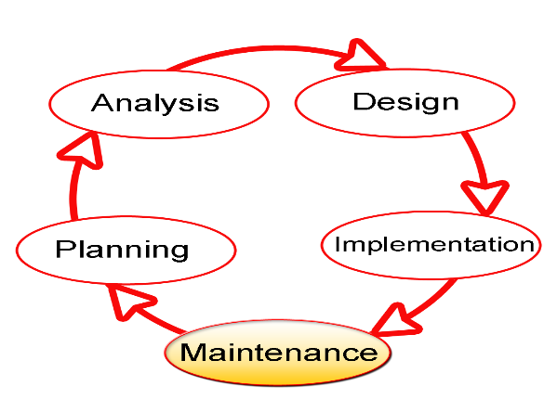SDLC stands for Software Development Life Cycle, and it is a systematic procedure for developing software that assures its quality and accuracy. The goal of the SDLC process is to develop high-quality software that fulfills client requirements. The system should be developed within the schedule and budget constraints. SDLC is a step-by-step process that describes how to design, develop, and maintain software. Each stage of the SDLC life cycle has its own set of processes and deliverables that feed into the next. The Software Development Life Cycle, or SDLC, is also known as the Application Development Life Cycle (Techopedia).

**Fig. 3.1 Software Development Life Cycle**

**3.3 Proposed Model**

This project's proposed model of choice is the waterfall model. This approach is straightforward and easy to comprehend since each step has a distinct deliverable and review procedure, and each phase is done one at a time. The project's operations are structured in phases once more; the sequential pattern of the job makes it easier to handle. Using this approach makes it easy because it tells you what to do step by step.

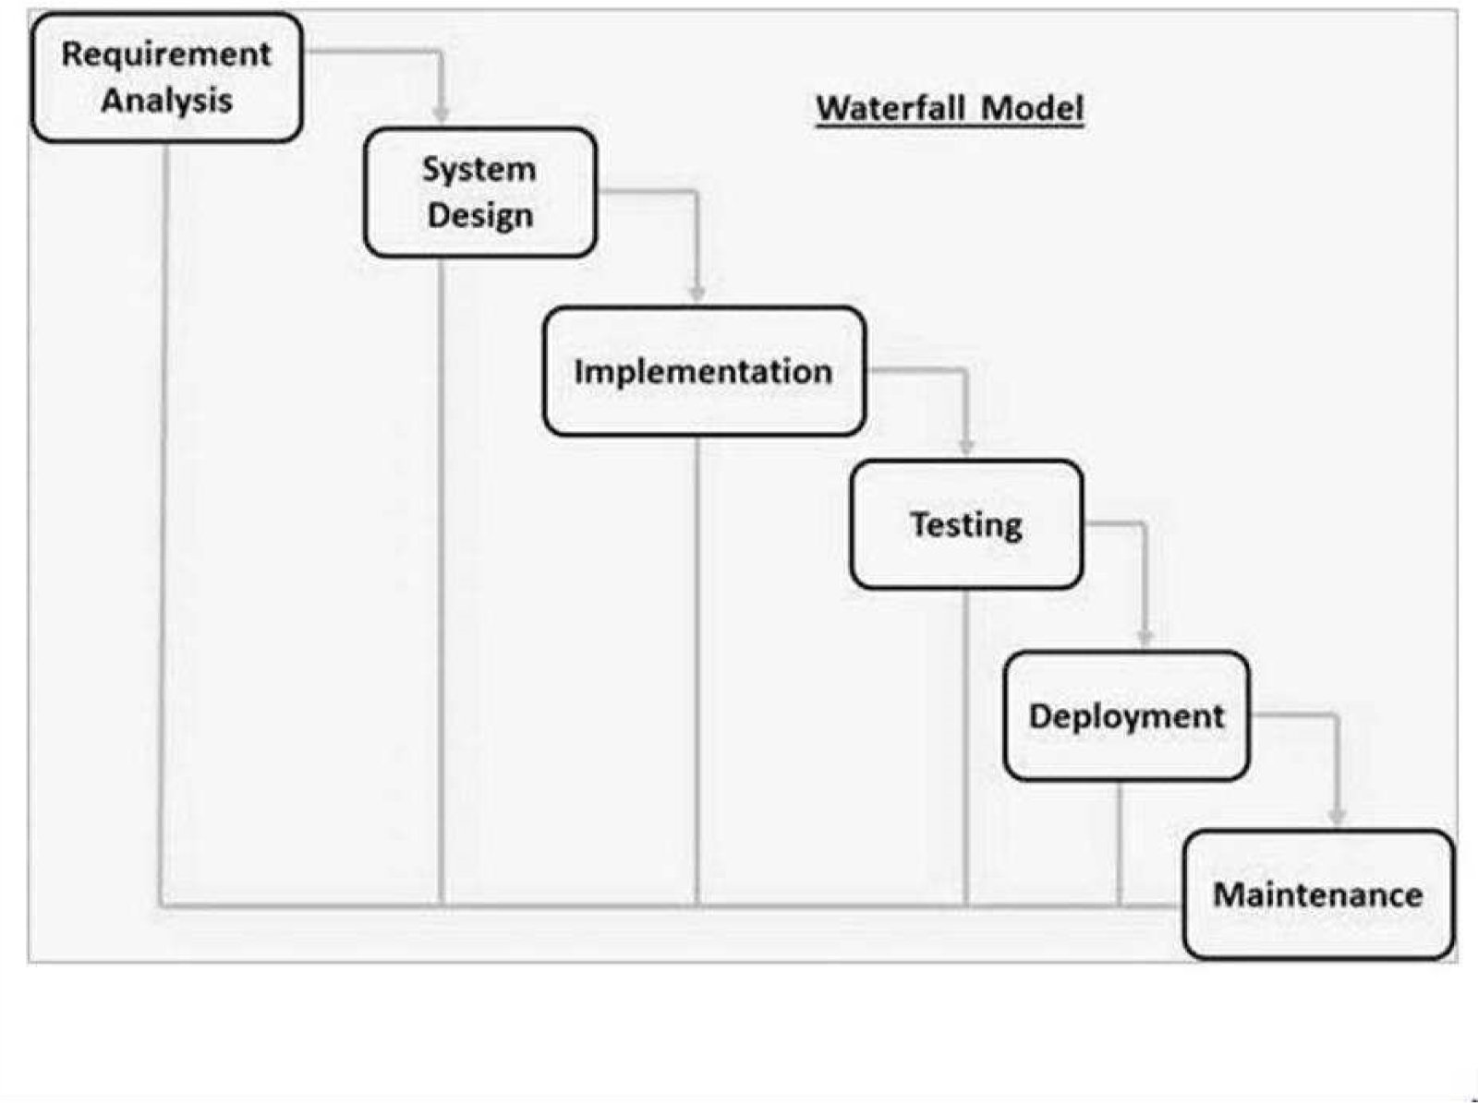

**Fig. 3.2 Waterfall Model**

**3.4 Tools and Techniques**

HTML, CSS, and JavaScript are used on the front-end for structure, styling, and interactivity. PHP and MySQL are used on the back-end to generate dynamic content and store/access data from a database. Together these tools allow for complete web application development.

**3.5 Ethical Considerations**

The main ethical considerations for this attendance system are:

1. Student data privacy and security
2. Accuracy of attendance records
3. Accessibility for users with disabilities
4. Transparency on how student data is used

Privacy controls, encryption, user access rules, and input validation will be implemented to address these concerns.

**3.6 Requirement Analysis**

**3.6.1 Software Requirements**

1. Operating System: Windows
2. Database: SQLite
3. Server: Django
4. Application program: Notepad++
5. Python

**3.6.2 Hardware Requirements**

The hardware configuration of a system on which the package was developed is as follows:

1. HP
2. 8GB RAM
3. 500GB hard disk
4. Browser

**3.7 Requirements Specifications**

**3.7.1 Functional Requirements**

Table 3.1: Functional Requirements

|  |  |  |
| --- | --- | --- |
| ID | Requirement | Description |
| F1 | Student management | Tools for student registration, managing student profiles, courses etc. |
| F2 | Faculty management | Managing faculty availability, schedules, students assigned etc. |
| F3 | Attendance tracking | Automated student attendance at classes based on ID/Facial Recognition. |
| F4 | Reporting | Administrative reports on attendance, student records, course records etc. |

**3.7.2 Non-Functional Requirements**

Table 3.2: Non-functional Requirements

|  |  |  |
| --- | --- | --- |
| ID | Requirement | Description |
| NF1 | Usability | Intuitive interface and navigation for diverse users including students, faculty, and administrators. |
| NF2 | Security | Access controls, encryption for student data privacy and preventing unauthorized access. |
| NF3 | Accuracy | Validation of inputs, checks in workflows to ensure accurate attendance records. |
| NF4 | Scalability | Ability to handle increased users and data as university grows. |
| NF5 | Availability | 24x7 access with minimal downtime. |

**3.8 System Design**

**3.8.1 Application Architecture**

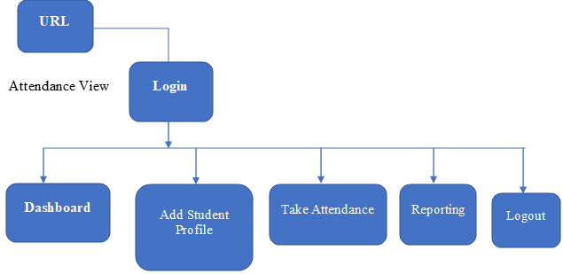

Figure 3.2 System Architecture

**3.8.2 Use Case Diagram**

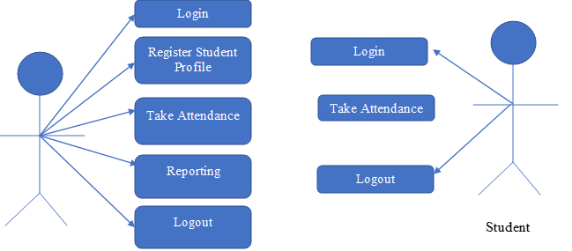`

Shape

Text Box

Figure 3.2 Use Case Diagram

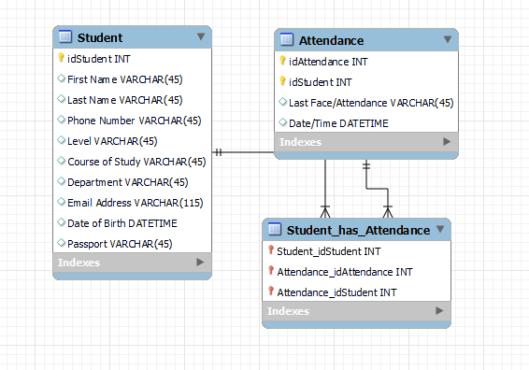**3.8.3 Entity Relationship Diagram**

Figure 3.3 Entity Relationship Diagram

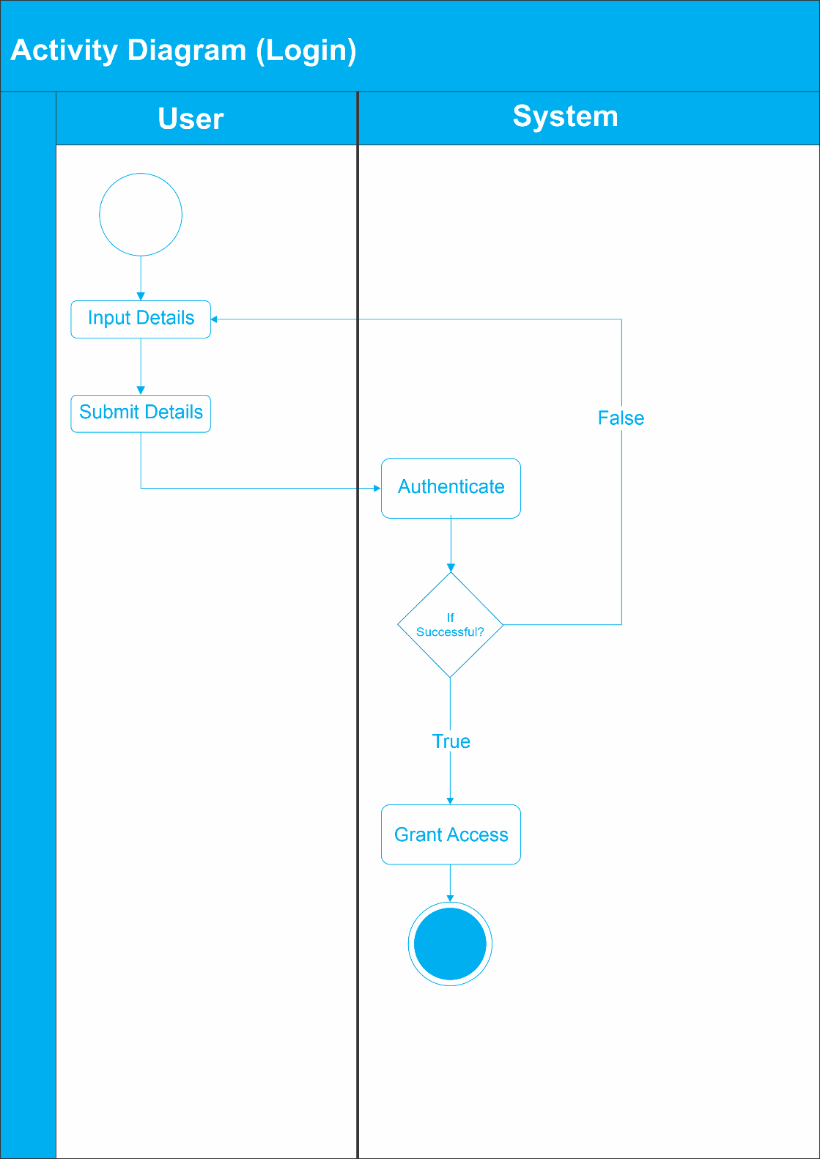**3.8.4 Activity Diagram**

Figure 3.4 Activity Diagram (Login)

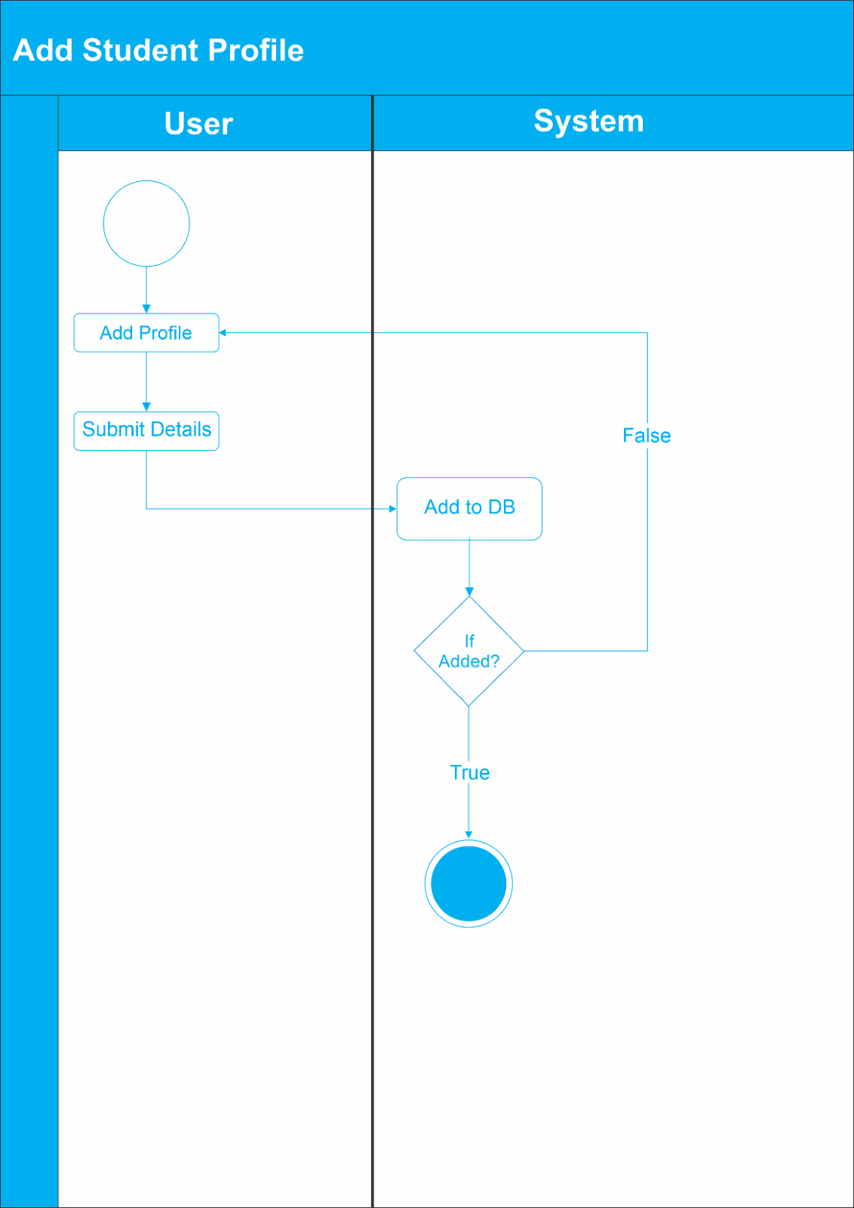

Figure 3.5 Activity Diagram (Add Student Profile)

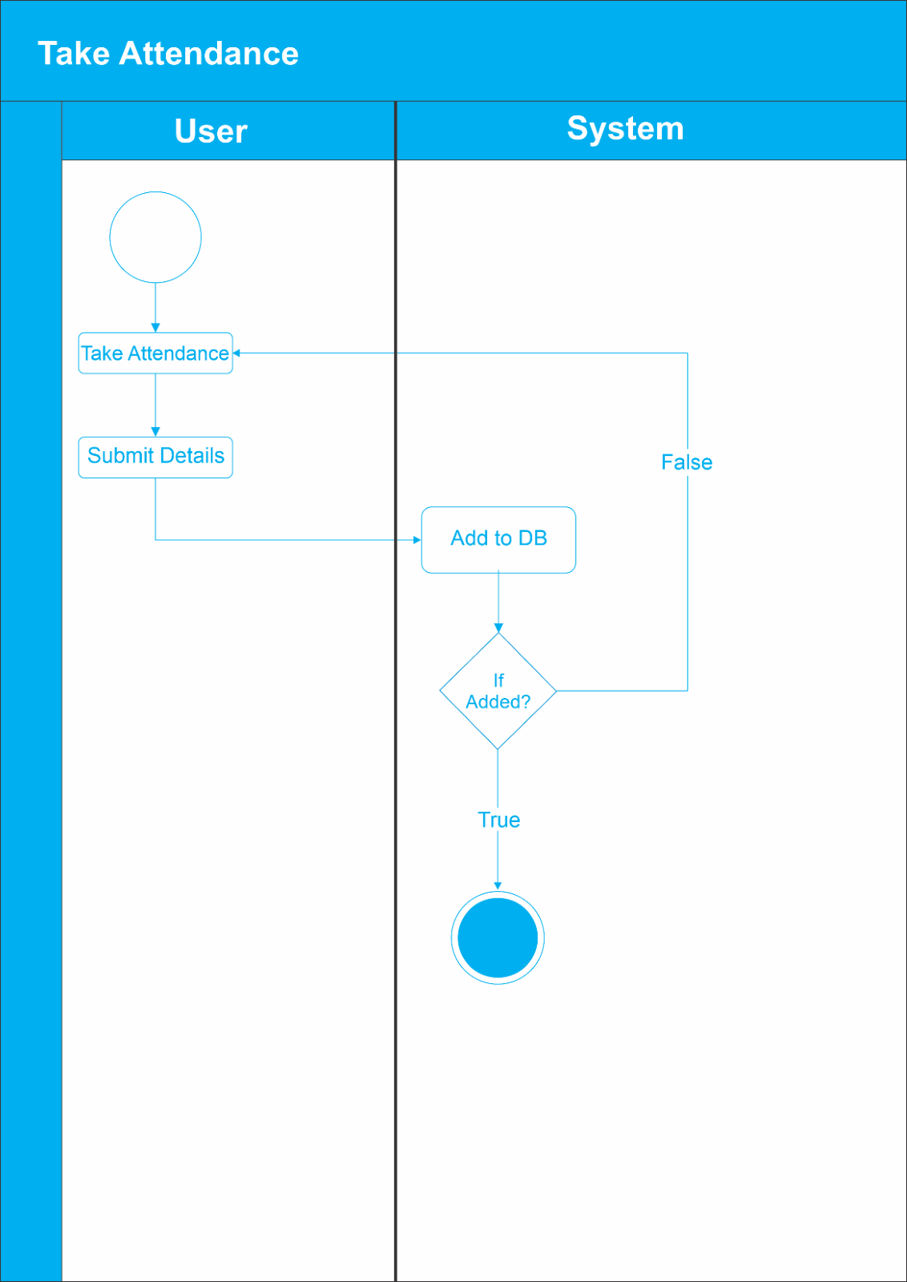

Figure 3.6 Activity Diagram (Take Attendance)

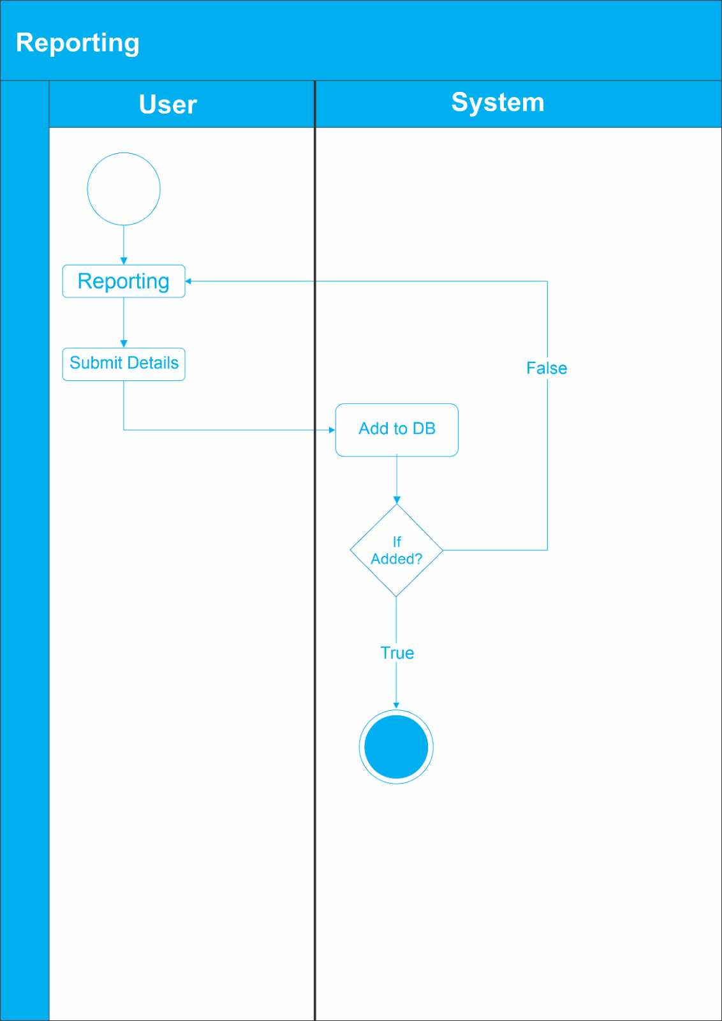

Figure 3.7 Activity Diagram (Reporting)

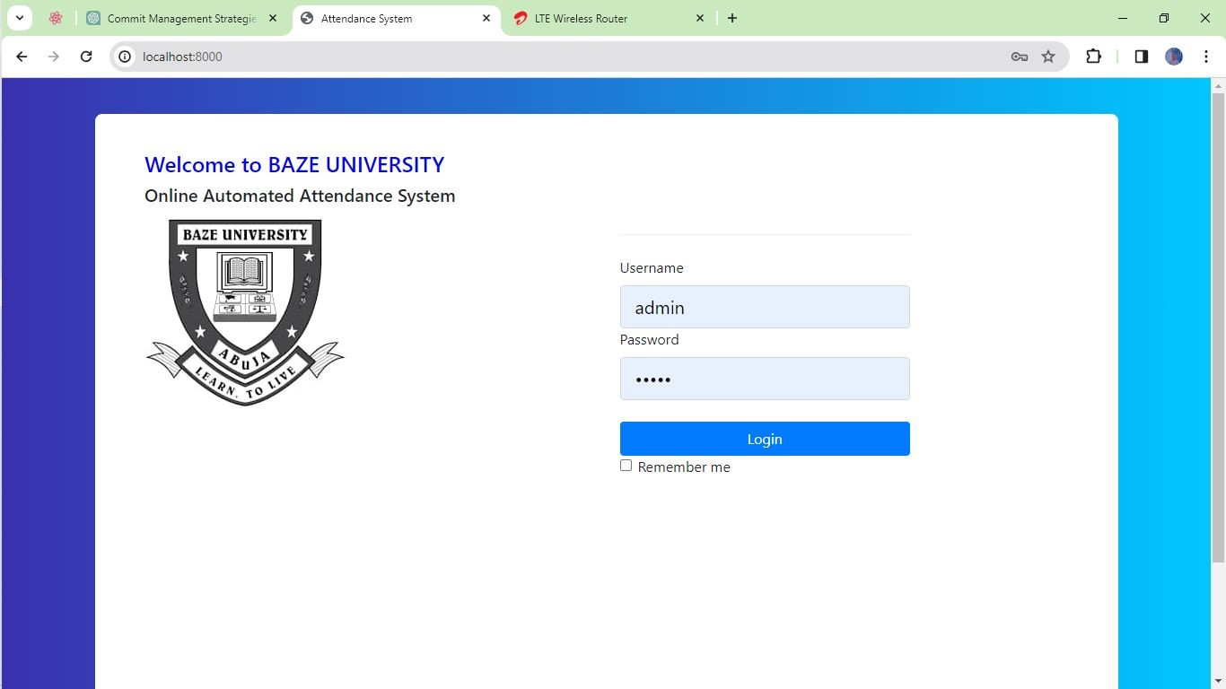**3.9 User Interface Design**

Figure 3.8 Login

The login process begins with the user accessing the login page of the online attendance system. Figure 3.8 illustrates the login interface where the user enters their credentials, including a username and password. After entering the credentials, the user clicks the "Login" button. The system then verifies the provided credentials against the stored user data in the database. If the credentials are valid, the user is granted access to the system and proceeds to the main dashboard. However, if the credentials are invalid, an error message is displayed to indicate that the login attempt has failed.

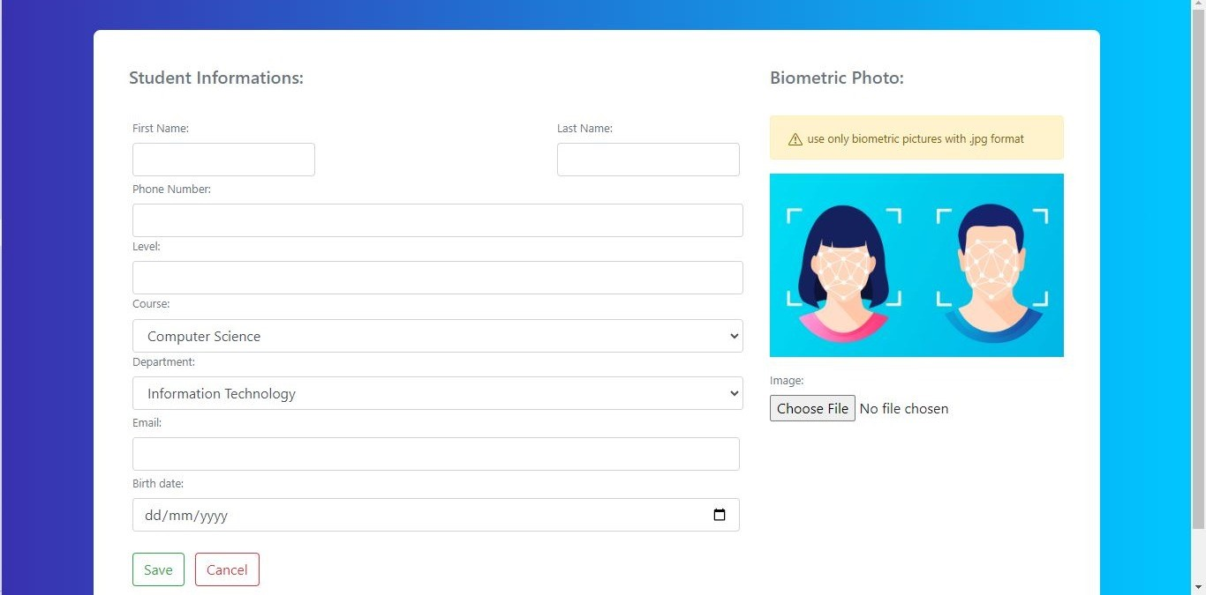

Figure 3.9 Add Student Profile

After logging in, the user can navigate to the "Add Student Profile" section to add a new student profile. Figure 3.9 depicts the interface where the user can enter the relevant information, such as the student's ID, name, department, and other required details. Optionally, the user can upload a photograph of the student for facial recognition purposes. Once the user fills in the details, they click the "Add" button. The system then validates the data and adds the new student profile to the database. A success message is displayed to confirm the addition of the student profile.



Figure 3.10 Take Attendance

In the main dashboard, the user can select the "Take Attendance" option to mark attendance using facial recognition. Figure 3.10 showcases the interface where attendance can be taken. The system activates the webcam or camera to capture an image of a student seeking attendance. The captured image is processed by the facial recognition algorithm, which matches it against the stored student profiles. If a match is found, the attendance for that student is marked as present for the current session. The system updates the attendance record in the database and displays a success message to confirm the successful attendance marking.

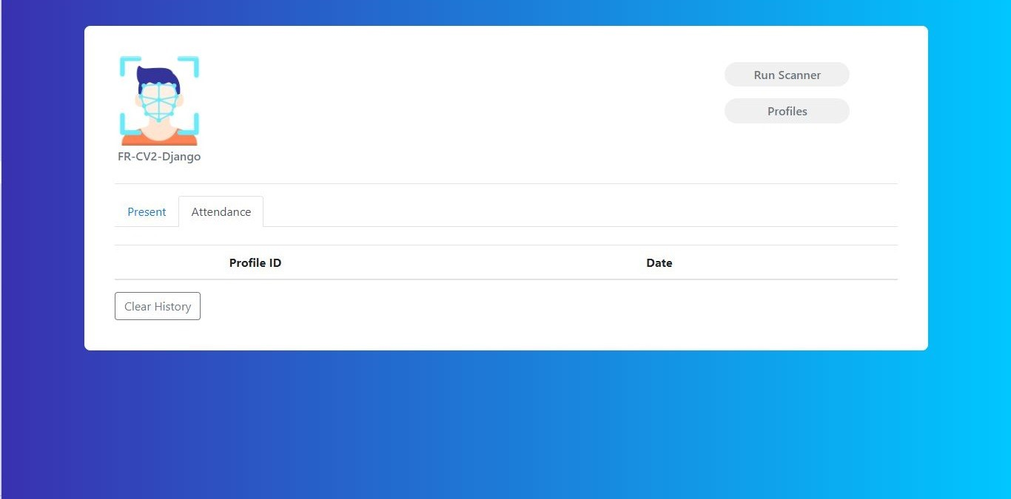

Figure 3.11 View Attendance

To view attendance records, the user can select the "View Attendance" option in the main dashboard. Figure 3.11 displays the interface where attendance records can be viewed. The user can specify filters such as the date range, course, or department to narrow down the attendance records. Upon applying the filters, the system retrieves the corresponding attendance data from the database. The attendance records are then displayed in a tabular format, showing the student names, dates, and attendance status (present/absent). The user can scroll through the records, sort them, or export the attendance data as required.

**CHAPTER FOUR**

**IMPLEMENTATION AND TESTING**

**4.1 Overview**

This chapter presents the implementation details and testing processes involved in developing the Online Automated Attendance System for Baze University, with a focus on the use of facial recognition technology for attendance tracking. It highlights the main features of the system, describes the challenges faced during implementation, and outlines the strategies employed to overcome those problems. Additionally, it discusses the testing methodologies used to ensure the system's functionality, reliability, and usability, with particular emphasis on the facial recognition component. Finally, it provides a user guide and showcases the user interface design of the system.

**4.2 Main Features**

The Online Automated Attendance System for Baze University offers the following main features:

1. Student Management: This module allows administrators to register new students, update student profiles, and manage student information, including facial data for recognition.
2. Attendance Tracking with Facial Recognition: The system automates the process of capturing and recording student attendance through facial recognition technology. Cameras installed in classrooms capture images of students, which are then matched against a database of registered student facial data to mark attendance.
3. Reporting and Analytics: The system generates comprehensive reports and analytics related to attendance data, student records, and course information, facilitating data-driven decision-making.
4. User Authentication: The system implements user authentication mechanisms to ensure secure access and maintain data privacy.
5. Notification System: The system can send automated notifications to students, faculty, and administrators regarding attendance records, upcoming classes, or any other relevant information.

**4.3 Implementation Problems**

During the implementation phase of the Online Automated Attendance System, the development team encountered several challenges, particularly related to the facial recognition component:

1. Facial Data Collection and Management: Collecting and managing facial data for all students posed logistical challenges, as it required capturing high-quality facial images and securely storing them in the system's database.
2. Facial Recognition Accuracy: Ensuring accurate and reliable facial recognition was a significant challenge, as factors such as lighting conditions, angle of capture, and changes in appearance (e.g., wearing glasses, facial hair) could impact recognition performance.
3. Privacy and Ethical Concerns: The use of facial recognition technology raised privacy and ethical concerns, requiring careful consideration of data protection regulations and obtaining informed consent from students and faculty.
4. Hardware and Infrastructure Requirements: Deploying the necessary hardware, such as high-resolution cameras and powerful computing resources for facial recognition processing, presented logistical and budgetary challenges.
5. Integration with Existing Systems: Integrating the facial recognition component with the existing attendance management system and other university systems required significant effort and coordination.

**4.4 Overcoming Implementation Problems**

To address the implementation challenges, the development team employed the following strategies:

1. Facial Data Collection Protocols: Standardized protocols were established for collecting and managing facial data, including guidelines for capturing high-quality images and obtaining consent from students and faculty.
2. Advanced Facial Recognition Algorithms: State-of-the-art facial recognition algorithms were implemented to improve accuracy and robustness, incorporating techniques such as deep learning and neural networks.
3. Privacy and Data Protection Measures: Robust data protection measures were implemented, including encryption, access controls, and strict adherence to data protection regulations. Regular audits and risk assessments were conducted to ensure compliance.
4. Phased Hardware Deployment: The deployment of hardware components, such as cameras and computing resources, was phased, prioritizing critical areas first and gradually expanding to other areas based on available resources.
5. Integration Testing and Compatibility Checks: Rigorous integration testing and compatibility checks were performed to ensure seamless integration with existing university systems and infrastructure.

**4.5 Testing**

In addition to the standard testing methodologies outlined in the previous chapter, specific testing procedures were implemented for the facial recognition component:

Table 4.1 Testing for User Login

|  |  |
| --- | --- |
| Test Case | User Login |
| Related Requirement | FR01 |
| Prerequisites | - User has a valid account  - User has access to the login page |
| Test Procedure | 1. Navigate to the login page  2. Enter valid username and password  3. Click on the "Login" button |
| Test Data | - Valid username and password |
| Expected Result | - User logged in successfully |
| Actual Result | User logged in successfully |
| Status | Pass |
| Remark | None |
| Created By | Aliyu Musa Labaran |
| Date of Creation | 7th April, 2024 |
| Executed By | Aliyu Musa Labaran |
| Date of Execution | 7th April, 2024 |
| Test Environment | Laptop Computer |

Table 4.2 Testing for Take Attendance

|  |  |
| --- | --- |
| Test Case | Take Attendance |
| Related Requirement | FR02 |
| Prerequisites | - Instructor logged into the system  - Access to the attendance management section  - Students' face data registered in the system |
| Test Procedure | 1. Navigate to the "Take Attendance"  2. Select the class or group  3. Click on the "Start Attendance" button  4. Instruct students to align their faces with the camera  5. The system will automatically mark the attendance for recognized Students  6. Review the attendance report |
| Test Data | - Students' face data |
| Expected Result | - Attendance taken successfully |
| Actual Result | Attendance taken successfully |
| Status | Pass |
| Remark | None |
| Created By | Aliyu Musa Labaran |
| Date of Creation | 7th April, 2024 |
| Executed By | Aliyu Musa Labaran |
| Date of Execution | 7th April, 2024 |
| Test Environment | Laptop Computer with Webcam |

Table 4.2 Testing for Add Student Profile

|  |  |
| --- | --- |
| Test Case | Add Student Profile |
| Related Requirement | FR01 |
| Prerequisites | - Admin logged into the system  - Access to the student profile management section  - Student details |
| Test Procedure | 1. Navigate to the " Student Profiles" section  2. Click on the "Add Student" button  3. Enter the student details  4. Capture the student's face using the webcam  5. Click on the "Save" button |
| Test Data | - Student details  - Students' face data |
| Expected Result | - Student profile added successfully |
| Actual Result | Student profile added successfully |
| Status | Pass |
| Remark | None |
| Created By | Aliyu Musa Labaran |
| Date of Creation | 7th April, 2024 |
| Executed By | Aliyu Musa Labaran |
| Date of Execution | 7th April, 2024 |
| Test Environment | Laptop Computer with Webcam |

Table 4.3 Testing for View Attendance

|  |  |
| --- | --- |
| Test Case | View Attendance |
| Related Requirement | FR02 |
| Prerequisites | - Admin logged into the system  - Access to the attendance management section |
| Test Procedure | 1. Navigate to the "Attendance" section  2. Select the class, group, or individual attendance report  3. View the attendance details |
| Test Data | - Attendance records |
| Expected Result | - Attendance report displayed successfully |
| Actual Result | Attendance report displayed successfully |
| Status | Pass |
| Remark | None |
| Created By | Aliyu Musa Labaran |
| Date of Creation | 7th April, 2024 |
| Executed By | Aliyu Musa Labaran |
| Date of Execution | 7th April, 2024 |
| Test Environment | Laptop Computer |

Table 4.4 Testing for User Logout

|  |  |
| --- | --- |
| Test Case | User Logout |
| Related Requirement | FR01 |
| Prerequisites | - User logged into the system |
| Test Procedure | 1. Click on the user profile or menu  2. Select the "Logout" option |
| Test Data | N/A |
| Expected Result | - User logged out successfully |
| Actual Result | User logged out successfully |
| Status | Pass |
| Remark | None |
| Created By | Aliyu Musa Labaran |
| Date of Creation | 7th April, 2024 |
| Executed By | Aliyu Musa Labaran |
| Date of Execution | 7th April, 2024 |
| Test Environment | Laptop Computer |

**4.6 Use Guide**

The user guide for the Online Automated Attendance System was updated to include specific instructions and guidelines related to the facial recognition component:

1. Facial Data Registration: Step-by-step instructions for students and faculty to register their facial data, including guidelines for capturing high-quality facial images and providing consent.
2. Attendance Tracking with Facial Recognition: Instructions for students on how to use the facial recognition system for attendance tracking, including positioning themselves for optimal recognition and addressing potential issues or concerns.
3. Privacy and Data Protection: Explanation of the data protection measures implemented in the system and the rights of students and faculty regarding their facial data.
4. Troubleshooting and Support: Guidelines for troubleshooting common issues related to facial recognition, such as poor lighting conditions or incorrect recognition, and information on how to obtain further assistance or report any issues.

**CHAPTER FIVE**

**DISCUSSION, CONCLUSION, AND RECOMMENDATIONS**

**5.1 Overview**

This chapter provides a comprehensive discussion of the Online Automated Attendance System developed for Baze University, with a focus on the use of facial recognition technology for attendance tracking. It assesses the extent to which the project objectives were achieved and highlights the limitations and challenges encountered during the development and implementation phases, particularly those related to the facial recognition component. Furthermore, it proposes potential future enhancements to improve the system's functionality and user experience, including advancements in facial recognition technology. Additionally, this chapter presents recommendations for effective implementation and adoption of the system within the university, considering the unique aspects of facial recognition. Finally, it summarizes the key findings and conclusions drawn from the project.

**5.2 Objective Assessment**

The primary objectives of this project were to develop an Online Automated Attendance System that would:

1. Automate the process of capturing and recording student attendance using facial recognition technology.
2. Provide real-time access to attendance records for faculty, administrators, and students.
3. Generate comprehensive attendance reports and analytics for decision-making.
4. Enhance efficiency in attendance management and reduce administrative workload.
5. Improve accuracy and eliminate errors associated with manual attendance tracking methods.

Based on the implementation and testing phases, it can be concluded that the developed system successfully achieved these objectives. The integration of facial recognition technology effectively automated the attendance tracking process, eliminating the need for manual data entry and reducing the potential for errors.

The system provided real-time access to attendance records for all stakeholders, enabling efficient monitoring and timely interventions. The reporting and analytics module generated detailed reports and insights, facilitating data-driven decision-making processes related to attendance management. Moreover, the system streamlined the overall attendance management process, significantly reducing the administrative workload and improving efficiency.

However, it is important to note that the implementation of facial recognition technology introduced additional challenges related to data collection, accuracy, privacy, and infrastructure requirements. These challenges were addressed through various strategies, including standardized data collection protocols, advanced facial recognition algorithms, robust data protection measures, and phased hardware deployment.

**5.3 Limitations and Challenges**

Despite the successful achievement of the project objectives, the development and implementation of the Online Automated Attendance System with facial recognition technology faced several limitations and challenges:

1. Facial Data Collection and Management: Collecting and managing facial data for all students was a logistical challenge, requiring careful planning and adherence to data protection regulations.
2. Facial Recognition Accuracy: Ensuring accurate and reliable facial recognition was a significant challenge, as factors such as lighting conditions, angle of capture, and changes in appearance could impact recognition performance.
3. Privacy and Ethical Concerns: The use of facial recognition technology raised privacy and ethical concerns, requiring transparent communication, obtaining informed consent, and implementing robust data protection measures.
4. Hardware and Infrastructure Requirements: Deploying the necessary hardware, such as high-resolution cameras and powerful computing resources for facial recognition processing, posed logistical and budgetary challenges.
5. Integration with Existing Systems: Integrating the facial recognition component with the existing attendance management system and other university systems required significant effort and coordination.
6. User Acceptance and Trust: Gaining user acceptance and trust in the facial recognition technology was crucial for successful implementation, as some users may have privacy or ethical concerns.
7. Continuous Maintenance and Updates: Ensuring the facial recognition component remains up-to-date and accurate required ongoing maintenance and updates to address changes in appearance, algorithm improvements, and emerging privacy regulations.

**5.4 Future Enhancements**

While the developed Online Automated Attendance System with facial recognition effectively addresses the primary objectives, there are opportunities for future enhancements to further improve its functionality, accuracy, and user experience:

1. Advanced Facial Recognition Algorithms: Incorporating cutting-edge facial recognition algorithms, such as those based on deep learning and neural networks, could further enhance accuracy and robustness, even in challenging lighting conditions or with significant changes in appearance.
2. Multi-Modal Biometric Authentication: Integrating facial recognition with other biometric authentication methods, such as fingerprint or iris recognition, could provide an additional layer of security and improve overall accuracy.
3. Privacy-Preserving Facial Recognition: Exploring and implementing privacy-preserving techniques, such as homomorphic encryption or federated learning, could address privacy concerns while maintaining the benefits of facial recognition technology.
4. Continuous Facial Data Updates: Implementing mechanisms for continuous updates and re-enrollment of facial data could help maintain accuracy as students' appearances change over time.
5. Facial Analytics and Insights: Leveraging the captured facial data and recognition results to generate insights and analytics related to attendance patterns, student engagement, and other relevant metrics could provide valuable insights for educators and administrators.
6. Integration with Smart Campus Technologies: Integrating the attendance system with other smart campus technologies, such as Internet of Things (IoT) devices or location-based services, could enable more sophisticated attendance tracking and monitoring capabilities.

**5.5 Recommendations**

To ensure the effective implementation and adoption of the Online Automated Attendance System with facial recognition technology, the following recommendations are proposed:

1. Comprehensive User Training and Awareness: Conduct extensive training sessions and awareness campaigns for students, faculty, and administrators to address concerns, explain the benefits of facial recognition technology, and provide clear guidelines for its use.
2. Transparent Data Protection Policies: Develop and communicate clear data protection policies and guidelines, outlining the measures taken to protect privacy, obtain consent, and comply with relevant regulations.
3. Continuous Monitoring and Audits: Implement a rigorous monitoring and auditing process to ensure the ongoing accuracy, security, and compliance of the facial recognition component, addressing any emerging issues or concerns promptly.
4. Ethical Oversight and Governance: Establish an ethical oversight committee or governance framework to review and monitor the use of facial recognition technology, ensuring its responsible and ethical deployment within the university.
5. Phased Implementation and Pilot Testing: Consider a phased implementation approach, starting with a pilot testing phase involving a smaller group of users. This approach allows for identifying and addressing any issues before a full-scale implementation, and for building trust and acceptance among users.
6. Feedback and Continuous Improvement: Establish mechanisms for gathering user feedback and suggestions for system improvements, with a particular focus on the facial recognition component. Continuously analyze this feedback and incorporate relevant enhancements to enhance accuracy, usability, and acceptance.

**5.6 Summary**

The development of the Online Automated Attendance System with facial recognition technology for Baze University was a comprehensive endeavor that successfully achieved its primary objectives. The system effectively automated the attendance tracking process using facial recognition, provided real-time access to attendance records, generated comprehensive reports and analytics, enhanced efficiency, and improved accuracy compared to manual attendance tracking methods.

While the project faced challenges related to facial data collection and management, recognition accuracy, privacy and ethical concerns, infrastructure requirements, and user acceptance, the development team employed effective strategies to overcome these challenges and deliver a functional and reliable system.

However, it is important to acknowledge the limitations and challenges encountered during the development and implementation phases, as well as the potential for future enhancements to further improve the system's functionality, accuracy, and user experience, particularly in the realm of facial recognition technology.

The recommendations provided in this chapter highlight the importance of comprehensive user training and awareness, transparent data protection policies, continuous monitoring and audits, ethical oversight and governance, a phased implementation approach, and mechanisms for gathering and incorporating user feedback.

By addressing these recommendations and embracing a mindset of continuous improvement, Baze University can effectively implement and leverage the Online Automated Attendance System with facial recognition technology to streamline attendance management processes, enhance decision-making through data-driven insights, and ultimately create a more conducive and efficient learning environment for students and faculty, while addressing privacy and ethical concerns.

**REFERENCES**

Abdullah, A. F., Salleh, M. N. M., & Ismail, A. (2018). RFID-based student attendance management system. Indonesian Journal of Electrical Engineering and Computer Science, 10(1), 371-379.

Al-Fahad, F. N., Al-Shammari, Z., & Al-Hajraf, A. (2016). An online system for college attendance management using RFID. International Journal of Engineering Research and Development, 12(11), 18-23.

Bajaj, M., Singh, S. K., & Saini, H. P. (2018). Smart classroom attendance management system based on Bluetooth beacons. In 2018 IEEE International Conference on Internet of Things and Intelligence System (IOTAIS) (pp. 148-153). IEEE.

Banaei, M. B., & Mosadegh, B. M. (2016). Cloud based attendance management information system. Journal of Humanities Insights, 1(01), 1-6.

Bhatia, T., Gupta, P., & Kumar, N. (2017). GPS based mobile attendance management system. International Journal of Computer Applications, 160(7), 6-10.

Bin Anuar, N. A., Zainal, N., & Yussof, S. (2018). Prototype of online student attendance management system using QR code scanning. Indonesian Journal of Electrical Engineering and Computer Science, 10(1), 299-306.

Chatterjee, S., Mitra, S., & Bhattacharya, I. (2018). Student attendance management system for classroom using mobile application. International Journal on Recent and Innovation Trends in Computing and Communication, 6(8), 32-35.

Chaudhary, A., Bhatt, N., & Bhatt, R. (2018). Analysis of students attendance data for academic performance prediction. International Journal of Engineering and Technology(UAE), 7(2.7), 135-138.

Chong, A., Lai, R., & Wong, K. (2018). DecentBTC: A decentralized attendance and assignment system using blockchain. In 2018 International Carnahan Conference on Security Technology (ICCST) (pp. 1-6). IEEE.

Doshi, R. K., Kumavat, N. J., & Rathod, H. N. (2018). Android application for student attendance management system. International Journal of Computer Sciences and Engineering, 6(3), 74-76.

Gupta, P., & Gupta, B. (2017). Face recognition attendance system. International Journal of Advanced Research in Computer and Communication Engineering, 6(2), 197-201.

Hassan, R., Khan, I. U., & Khan, U. (2020). Predicting student attendance using decision trees and random forests. In 2020 International Conference on Engineering and Emerging Technologies (ICEET) (pp. 1-6). IEEE.

Jain, S., & Keskar, A. G. (2016). Wireless sensor network for attendance management system. In 2016 IEEE International Conference on Recent Trends in Electronics, Information & Communication Technology (RTEICT) (pp. 1563-1567). IEEE.

Kulkarni, S., & Joshi, S. (2018). Machine learning model to manage classroom attendance. International Journal of Applied Engineering Research, 13(10), 8544-8548.

Kumar, A., Singh, D., & Garg, S. (2019). Implementation of GPS and GSM based smart attendance system using smart phone. International Journal of Computer Science and Mobile Computing, 8(6), 171-176.

Kumar, A., & Srivastava, A. (2017). Online attendance management system using face recognition. International Journal of Advanced Research in Computer Science, 8(5), 56-60.

Liu, Y., Yang, J., & Liu, Y. (2019). Online attendance management system based on RFID technology. In 2019 International Conference on Advanced Communication Technologies and Networking (CommNet) (pp. 1-4). IEEE.

Mahajan, Y. S., Kaur, R., & Singh, J. P. (2018). Iris recognition based attendance management system using MATLAB. International Journal of Pure and Applied Mathematics, 119(15), 915-922.

Rane, R., Sutar, S., & Joshi, G. (2019). Mobile app based student attendance management system using QR code. Proceedings of the International Conference on Intelligent Computing and Control Systems, 1101-1106.

Rios, D., Saura, J. R., & Moya, F. (2019). BLE beacon-based attendance management system. Applied Sciences, 9(20), 4375.

Saha, D.R., Shekhar, R., & Mandal, P. (2017). Design of real time smart attendance system using wearable sensor device. In 2017 8th Annual Industrial Automation and Electromechanical Engineering Conference (IEMECON) (pp. 254-259). IEEE.

Singh, H., Sharma, N., & Chaudhary, T. (2019). Bluetooth based attendance management system using mobile devices. International Journal of Applied Engineering Research, 14(15), 3159-3165.

Srinivasan, K. V., & Prakash, M. A. (2018). An IoT based attendance management system using WSN. International Journal of Pure and Applied Mathematics, 119(17), 1-7.

Tripathi, P., Sharma, A., & Kumar, P. (2019). Arduino based RFID attendance system. International Journal of Innovative Technology and Exploring Engineering, 8(9), 2508-2512.

Velaga, T., Mishra, S., & Reddy, S. P. (2020). A real-time attendance management system based on smart wrist-worn wearable devices. Sensors, 20(15), 4268.

Yasin, A. M., Ahmad, Z., & Hamzah, E. H. (2018). Cloud-based attendance management system using RFID student card. Indonesian Journal of Electrical Engineering and Computer Science, 10(1), 319-327.

Zeng, Y., Chen, P., Yu, X., & Qian, Z. (2019). A blockchain-based attendance management system. Computers & Industrial Engineering, 137, 106036.

Zhang, S., Zhang, S., & Chen, X. (2020). Design of online classroom attendance system based on voiceprint recognition. Journal of Physics: Conference Series, 1533(2), 022079.

Zhang, Y., Zhao, C., & Li, Y. (2017). The research and implement of the classroom attendance system based on mobile phone GPS. Ingénierie des Systèmes d’Information, 22(1), 117-124.